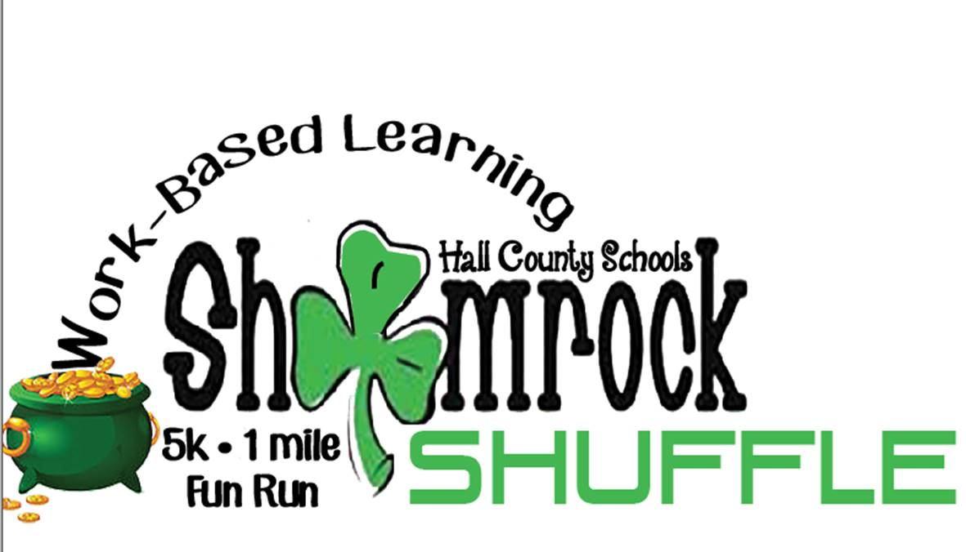

Dear Community Member:

The 2nd Annual ***Shamrock Shuffle 5K and 1 mile Fun Run*** will be held on March 14, 2020 at Laurel Park in Gainesville, Georgia. Through participation in this event, community businesses and local corporations such as yourself, will be contributing to the Hall County Schools Work-Based Learning programs and support county-wide initiatives. It is also a great way to support your local schools and gain exposure and public recognition within our Hall County Community.

 **Work-Based Learning** is learning that results from work experience designed to increase the knowledge and skills of the student. The Work-Based Learning program would not be possible without the support of our local business partners in Hall County. These businesses act as mentors, helping train students with critical skills needed to be successful in the world of work. Thank you to our current business partners and we encourage all businesses to get involved.

The attached form provides details on the three sponsorship levels available. You can email your questions to [deana.harper@hallco.org](mailto:deana.harper@hallco.org) or [suzanne.haynes@hallco.org](mailto:suzanne.haynes@hallco.org). Completed forms should be mailed by February 14, 2020, to the following address:

Deana Harper   
North Hall High School  
4885 Mt. Vernon Road  
Gainesville, GA 30506

Thank you for your consideration and participation for this exciting event!

Hall County Coordinators  
Work-Based Learning Students